**Report- Project Exam- Microsite Space technology**

I have completed this project exam through three deliverables. The first deliverable consisted of functional specification, project planning document and a Gantt chart. The second week, I delivered a document for target audience, personae, storyboard and wireframes. During the last three weeks I finished the final delivery of the complete microsite. I wanted to make a microsite that appealed to both government and every-day people. It could just be for people interested in learning more about space technology, but also for people interested in getting more involved.

**Week 1**

I started this project by reading the assignment and gathering some facts. I went through all the external resources and looked for inspiration on different sites on the internet like SpaceX, NASA and examples of other microsites. Then I filled out all the information in the functional specification document and started writing down all the elements I needed to complete this exam.

For the second part, I wrote the project planning document with the functional specification.

I made a list of elements to include in this project like use case, personae´s, prototyping, HTML & CSS, JavaScript, design, SEO, target audience and graphic design. I did the research first, then the sketches and personae´s/storyboards. After this, I chose colors, design, APIs and made a wireframe of the microsite. Next, I was to start building HTML and adding CSS. Further on- JavaScript and testing it. For last, I was going to write a report on this process.

I then put them inside the Gantt Chart where I planed the process and how much time I would spend on each of them.

The Gantt Chart looks like this:



**Week 2**

I started week two with creating the target audience for this microsite. After some research on the website of SpaceX, I found that one of their goals are to build rockets so that people can go to other planets and also to make them reusable. My target audience looks like this:

**Target audience:**

**What goals do they have?**

* Affordable prices and reusable rockets
* Buy satellites to be put in orbit
* Sending people to other planets

**What type of people are they?**

* Government
* Military

**What are their interests?**

* Curious about other planets
* Space technology
* Exploring the possibility of life on other planets

**Which age group are they?**

* Age range from 25-60

**Which gender are they?**

* Men and women

**What challenges do they have?**

* Too expensive
* Technology to make it reusable

When I was going to make my personae, I thought this should be one from the government since these are the people interested in space technology, so I made one for that, but later I found that I actually would have wanted one for every day people since the goal of SpaceX is to make it possible for everyone to travel to other planets with their reusable rockets. So this is something that I would have done differently, by adding another personae.

The personae´s I created is this:



Moving on to the storyboard, this was based on my personae, which is government people, but like with the personae, I would have wanted to make another one for every day people.

The storyboard looks like this:



The last part of week two- wireframe, looks like this:

**Home: Live feed:**

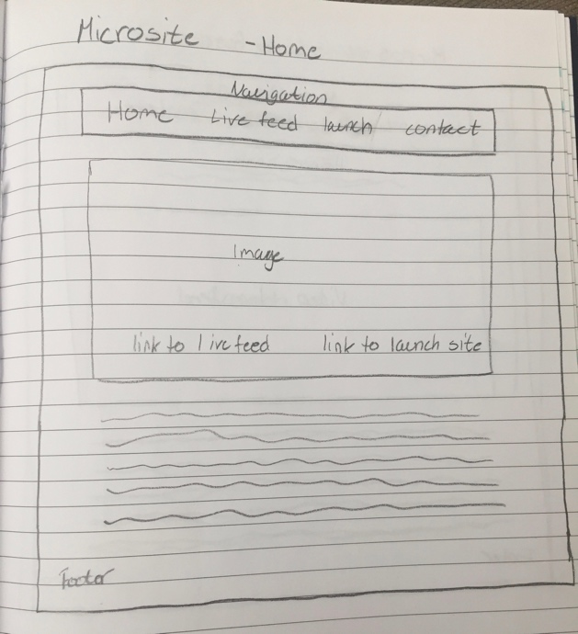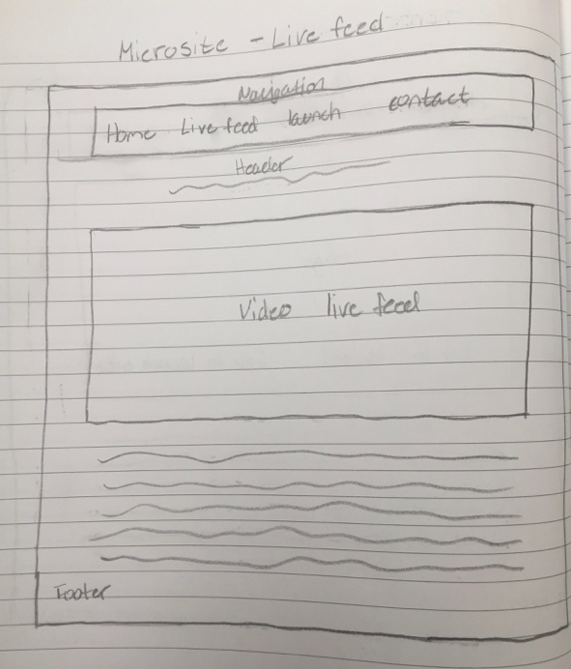

**Launch: Contact:**

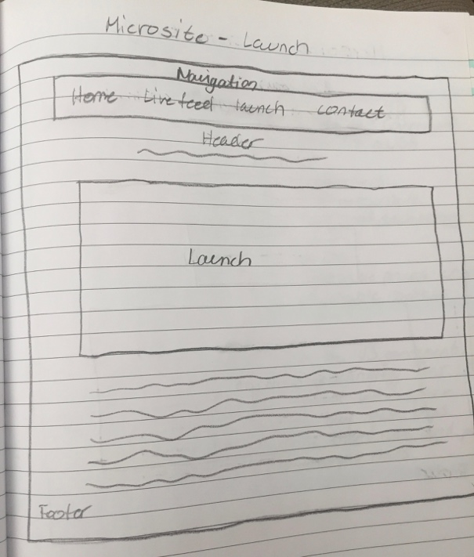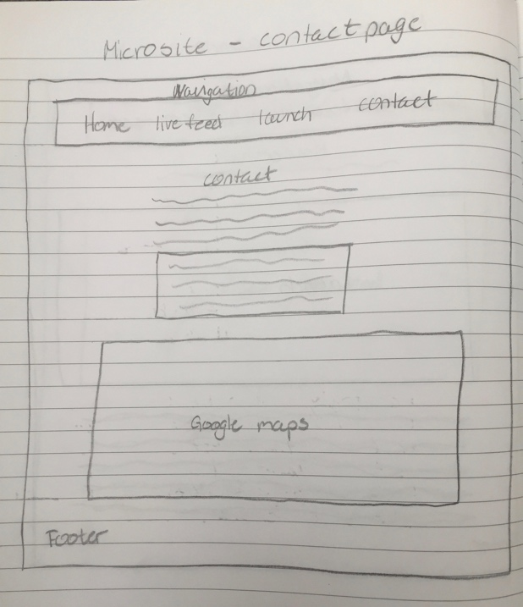

I think the wireframes make a good picture of how the site where to look like, but as I where adding the CSS, I wanted to make some changes. The “home” site is changed to “About” because I think it´s more relevant with an “about” page to give people an impression of what this site is about, and by also calling it “about”, this makes it a bit clearer. For the “live feed” page, I kept it the same as thee wireframe, but I wanted to keep it cleaner by only showing the live feed, but I added a link to more information underneath instead.

When I was going to make use of the API, I changed the look of this site. I choose to only have the launch updates and rather click them for more information on a different page.   
I wanted to keep the contact page simple and not too messy, so I decided to not go with google maps here, but only information on why to get in touch and then complete it with the contact form.

Although I planned it to look a bit different than it actually turned out, a lot of the elements are the same, and I think this looks much better than what I first saw, doing the wireframes.

**The complete project**

When I got to week three, I researched for images and colors to use and what type of fonts I wanted. I imported “heebo”, “lato”, “roboto” and “raleway”. I think these fit well together and also looks nice. I went to pixabay.com to find a background. I had in mind to use a picture of space, but also with some color, but not too much, since I think that would make it a bit messy.   
I found the images for my “about” site on SpaceX gallery, because I felt it would be a better match for my site since it is about space technology and for SpaceX. I used adobe color to get some of which I wanted to use from my background image. I choose the colors wine red, grey, white, red, turquoise and black. After picking out images, colors, typography and researching which API I needed, this is where I started to think about changing up the HTML structure.

I used a header “Space technology”- this is short and easy to see since it´s in white on dark background. The user gets a quick and clear impression on what this site is about. The navigation is made easy to use with only the text and wine-red color, because I think it makes it easy and clean. When you hover over or click to stay on one of the sites, the navigation text turns grey. This makes it easy to see which site is active and that it´s clickable.

**About site**

For the “about” site, I wanted to bring in more images than I first had in my wireframe. As a user, I think it would be more interesting to have more images to look at, so I chose to display these in two columns of three. After these, I put in some info text with “what we do”, to give the user a good overview of what the page is about and who it is for. I think it gives the user a quick feeling of the site so that’s why I chose to keep it short and add more information through links underneath. I put in links which will open in a new browser so that the user won´t have to leave the site.

**Live feed site**

The only thing I wanted on this site was a video of live feed rocket launch, and so I linked a youtube video from SpaceX on here, but I also added a link for more information related to rocket launched underneath.

**Launch site**

At the launch site, I used a few API´s to get direct information about all the launches. Firstly it´s only short info about the dates and type of rocket- together with an image, but if you click “view more”, it takes the user to a different/ new site where there is a countdown placed in red because it´s easy to see. On this site there are a bit more information describing the rockets and google maps for where it´s going to be launched. I think this is very easy to use because the “view more” button is in bright turquoise and the countdown text is in a clear red color. There are different “sections” displaying different information. Firstly, the countdown to clearly see when the launch is happening, one section for information and another for google maps.

**Contact site**

When I created the contact page, I wanted the user to get some information about what they were to get in touch about. That’s why I placed a few paragraphs at the top of the page. It lets the user decide if this is something that´s relevant and most importantly- why they should be contacting us. I wanted to give this site a bit color, but I didn´t want to frame the form, since I think it looked a bit boring, so I let the background image appear through.

**HTML, CSS and JavaScript**

I created five sites for the HTML: index, live feed, launch, launch details and contact. I also created one external CSS file and one external JavaScript file.   
In my CSS, I started with importing the fonts I decided to use. I worked from the start to finish, beginning with what is common for all the files like the background and then moved on with doing one site at a time. I finished with adding a bit @media to the microsite to get it both mobile and tablet responsive.

In JavaScript, I have only written code for JSON/ API. I have tried previous to do a validation of a contact form, but I don´t get it quite right so I tried to use the example I got from my teachers as a guideline to do the validation of the contact form. But I couldn’t get it to work since I only used it to try my own way but with some guiding. I have done it differently before, but that one, I couldn’t get to work without using “alert”.

**Conclusion**

When I first read through this project exam, microsites where something I actually hadn´t heard being used before. But when I saw a few examples, I obviously had seen them before, but I still had to do some research to get it straight how I wanted to approach this project.

After a bit of research, I thought I got a clear view of what I wanted to do. I made all the research and deliverables for the first two weeks as I first thought I would want it. But I noticed later, that there were a few things that I wanted to change as I moved along. But despite these changes, I think that the microsite gives a clear message of what it is about and for. Also, I think the colors, images and typography match well together and represents space technology.

**Link to GitHub repository:**

**Sources:**

* <https://api.nasa.gov/index.html#live_example>
* <https://api.nasa.gov/api.html#authentication>
* <https://github.com/r-spacex/SpaceX-API/wiki>
* <https://docs.spacexdata.com/view/2025350/RWaEzAiG/?version=latest>
* <https://spaceflightnow.com/launch-schedule/>
* <https://www.nato-pa.int/download-file?filename=sites/default/files/2018-12/2018%20-%20THE%20FUTURE%20OF%20SPACE%20INDUSTRY%20-%20BOCKEL%20REPORT%20-%20173%20ESC%2018%20E%20fin.pdf>
* <https://www.youtube.com/watch?v=8A2nJd9Urk8>
* <https://www.rocketlaunch.live>
* <https://www.spacex.com>

Media:

* <https://www.spacex.com/media>
* <https://pixabay.com>

User guidelines:

* <https://www.nasa.gov/multimedia/guidelines/index.html>